***CHEMISTRY 362***

# *Descriptive Inorganic Chemistry*

M. Y. Darensbourg

Final Examination

May 6, 2019

**An Aggie does not lie, cheat or steal or tolerate those who do.**



Please affirm this code by signing on the last page of this examination. Thanks!

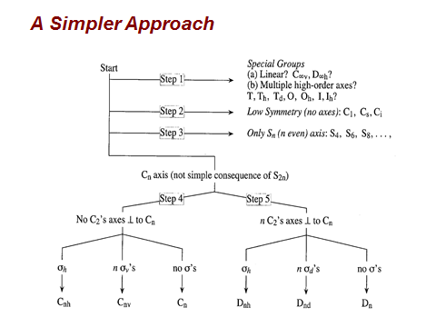

***See last page for even more useful information!***

1. Give the Lewis structures for the following molecules or molecular ions; use VSEPR to predict their molecular geometry and give a drawing of that structure. Give the oxidation state of the central atom in each structure.

|  |  |  |  |  |
| --- | --- | --- | --- | --- |
| **Molecule or molecular ion** | **Oxidation state of central atom(s)** | **Lewis structure** | **VSEPR/**  **Molecular geometry** | **Principal rotation axis and Symmetry Point group** |
| CO2 |  |  |  |  |
| PF2Cl3 |  |  |  |  |
| XeF4 |  |  |  |  |
| SF4 |  |  |  |  |

1. Complete the following equations:

a) Na2O + H2O

b) SO3 + H2O

c) P4O6 + H2O

d) PF3 + F2

e) K° + H2O

1. Consider the diatomic molecules or ions: O2, O2**−**, O22**−** and NO
2. 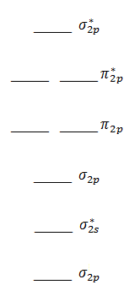Give the MO configuration for these, assign electrons, and give the bond order. (i.e., (1s21s2)σ2s2σ…)

Bond order

O2 _________________________________ ________

O2**−** _________________________________ ________

O22**−** _________________________________ ________

NO _________________________________ ________

σ2ss

1. Now, match the property to the molecule: O2, O2**−**, O22**−** and/or NO.

________ a) molecule(s) or ion(s) with Ground State Term Symbol = 3Σ

________ b) molecule(s) or ion(s) with Ground State Term Symbol = 1Σ

________ c) molecule(s) or ion(s) with Ground State Term Symbol = 2Π

________ d) molecule(s) or ion(s) whose bond order increases when oxidized by one electron (X2 - e‾ 🡪 X2+)

________ e) molecule(s) or ion(s) whose bond order decreases when reduced by one electron (X2 + e‾ 🡪 X2‾)

________ f) molecule(s) or ion(s) that is (are) paramagnetic

________ g) molecule with greater bond energy

________ h) the “superoxide” anion

________ i) molecule or ion with longest O—O distance

1. Electrochemical potential table is given on last page of the exam along with equations needed.

A) The reaction of O2 with hydrogen, H2, may be configured into a fuel cell—assume it looks something like the following with gases entering from both sides. Place the following words in the appropriate places: H2, O2, anode, cathode, electrolyte, electric current.

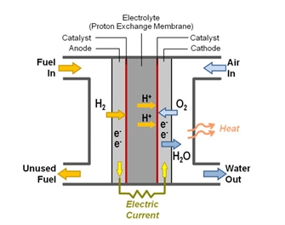

1. Identify the reactions occurring at each electrode:

anode:

cathode:

1. Give the overall chemical equation for the redox reaction and calculate the standard potential, E° for such an electrochemical cell. What is the value of ΔG° under standard conditions?
2. On the diagram, indicate the direction of electron flow.
3. Consider the Born-Haber cycle below.

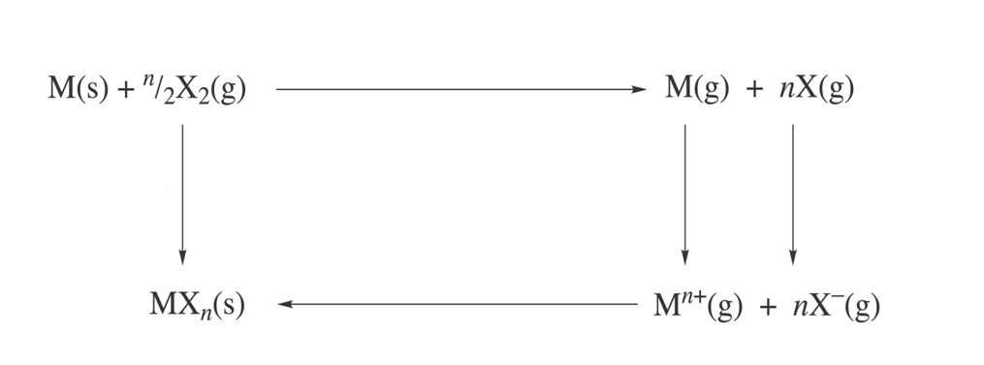

1. Label each arrow on the cycle at right with the appropriate thermodynamic process.
2. Using the data provided for M = lithium and X2 = fluorine, calculate the heat of formation for LiF (s).
3. Lattice enthalpy change or Lattice Energy = - 1239 kJ/mol
4. Electron affinity enthalpy = - 328 kJ/mol
5. Ionization energy = + 531 kJ/mol
6. Bond dissociation Energy (1/2 F2 → F (g)) = + 79 kJ/mol
7. Atomization or Sublimation Energy = + 161 kJ/mol
8. Standard Enthalpy of Formation = ???? kJ/mol
9. The theoretical lattice energy is given by the following equation. Define A and Z.
$$∆U = \frac{-NAZ^{+}Z^{-}e^{2}}{4πε_{0}r_{0}}(1-\frac{1}{n})$$

10. In contrast to the lattice energy of NaCl, -788 kJ/mol, that of MgO is -3790 kJ/mol and of CsCl is -660 kJ/mol. What is (are) the predominating factor(s) in the theoretical lattice energy equation, given in C., that accounts for these disparities?

|  |  |
| --- | --- |
| r+ of Na+ | 1.16 Å |
| r+ of Cs+ | 1.88 Å |
| r+ of Mg2+ | 0.86 Å |
| r+ of Cl‾ | 1.67 Å |
| r+ of O2‾ |  |

1. Select and circle the correct answer from the possibilities:
2. Product of radioactive decay from the reaction: 238U ➔ 4 He + ???

234U 238Th 234Th 234Pa

1. Ground state term symbol for atomic O: 3P 2P 1D 3Σ
2. An atom or ion with largest Zeff on outermost electron: B C N O
3. The atom or ion of largest Ionization Energy: B C N O
4. The hybrid orbital make up of the lone pairs on the middle atom in NO2̄.

Mainly sp2 (s, px, py) sp3 sp (s, pz) sd2

1. Molecule with highest s character in lone pair(s).

NH3 PH3 H2O CH4

1. Molecule with strongest H-bonds to itself in a condensed media

NH3 PH3 H2O H2S

1. The strongest oxidant

Lio H2 F2 O2

1. Molecule with strongest acid-base interaction with NH3

BF3 BMe3 PMe3 BH3

1. The linear combination of atomic orbitals that make the antibonding orbital of one bridging hydride in diborane: H2B(µ-H)2B’H2.

*i*) Hbr(1s) + [B(sp3) + B’(sp3)]

*ii)* Hbr(1s) - [B(sp3) + B’(sp3)]

*iii)* Hbr(1s) - [B(sp3) - B’(sp3)]

*iv)* Hbr(1s) + [B(sp2) - B’(sp2)]

k) Highest boiling point: H2S NH3 HF H2O

1. The hardest base: F- S2- PR3 I-
2. Most likely to have equilibrium lying to the LEFT:

*i*) AlI3 + 3 NaF = AlF3 + 3 NaI *iii*) BF3H**–** + BH3F**–** = BF4**–** + BH4**–**

*ii*) CuI2 + 2 CuF° = CuF2 + 2 CuI *iv*) CdI2 + MgF2 = CdF2 + MgI2

1. The strongest Bronsted (protonic) acid

H2O [Fe(H2O)6]3+ [Fe(H2O)6]2+

1. A p-type semi-conductor

Si Si doped with As Si doped with Ga

p) Not an intrinsic semi-conductor: Si Ge GaAs diamond

q) According to valence-bond theory, the orbital overlap that makes up one Cu2+–NH3 coordinate covalent bond in Cu(NH3)42+:

empty Cusp3 + filled Nsp3 filled Cusp3 + empty Nsp3

empty Cudsp2 + filled Nsp3 half-filled Cud2sp3 + empty Nsp3

1. An inner orbital complex:

diamagnetic Fe(CN)64ˉ paramagnetic FeF64ˉ

diamagnetic ZnCl42ˉ paramagnetic Ni(NH3)62+

s) From Crystal Field Theory, the highest energy d orbital in the d-orbital splitting diagram for trans-[CoCl2(NH3)4]**–**. dxz, dyz, dxy dx2-y2 dz2

1. The magnetism and color of oxygenated heme (as in hemoglobin; your blood)

i) paramagnetic and blue; ii) paramagnetic and red;

iii) diamagnetic and blue; iv) diamagnetic and red.

1. A) The intermediate in the following ligand exchange process for square planar platinum is pentacoordinate. Give a drawing of that intermediate, and give the d-orbital splitting diagram for the reactant and the intermediate and assign electrons.

PtCl42- + NH3 🡪 intermediate 🡪 [PtCl3(NH3)]‾

B) What is the expected rate expression for the reaction? That is, express by an equation how the rate of the reaction depends on the concentration of the reactants?

Rate = -d[PtCl42-]/dt =

1. The reaction profile for reaction A) is given below. Place the labels: ╪1, ╪2, I, Eact (for the rate-determining step), the transition state(s) and intermediate(s), and ΔG on the drawing.

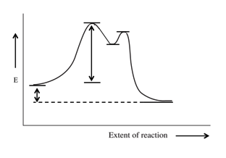

1. Vaska’s complex, **(a**), is made up of a chloride anion, a carbon monoxide or carbonyl, and two triphenylphosphine ligands. It reacts with H2 and with O2 to yield products as shown. Answer the questions below.



* + 1. Give the official (IUPAC) name of Vaska’s complex: _________________________________________________________
    2. Give the oxidation states of Ir in (**a**)_______ (**b**)_______ (**c**)_______
    3. List the number of electrons in the coordination sphere of Ir for

(**a**)_______ (**b**)_______ (**c**)____________

* + 1. According to the valence bond, hybrid orbital approach, the set of hybrid orbitals on Ir that accounts for the ligand to metal coordinate covalent bonds in (**a**) is (circle the correct answer): **sp3, dsp2, dsp3, or d2sp3** while in (**b**) it is **dsp2, dsp3, or d2sp3**.
    2. Assuming all ligands are roughly equivalent, give the Crystal Field d-orbital splitting diagrams for **(a**) and (**b**) and assign electrons to each diagram. Place d-orbital labels on the levels.
    3. On the following figure, sketch the π-type orbital interactions/overlap in the Ir-Cl bond and in the Ir-CO bond for (**a**). Label all orbitals. What is the major difference in the bonding /orbital overlap between the two ligands, Cl¯ and CO?

Cl Ir CO

* + 1. Why is the trans-isomer of (**a**) thermodynamically more stable than the cis?

1. 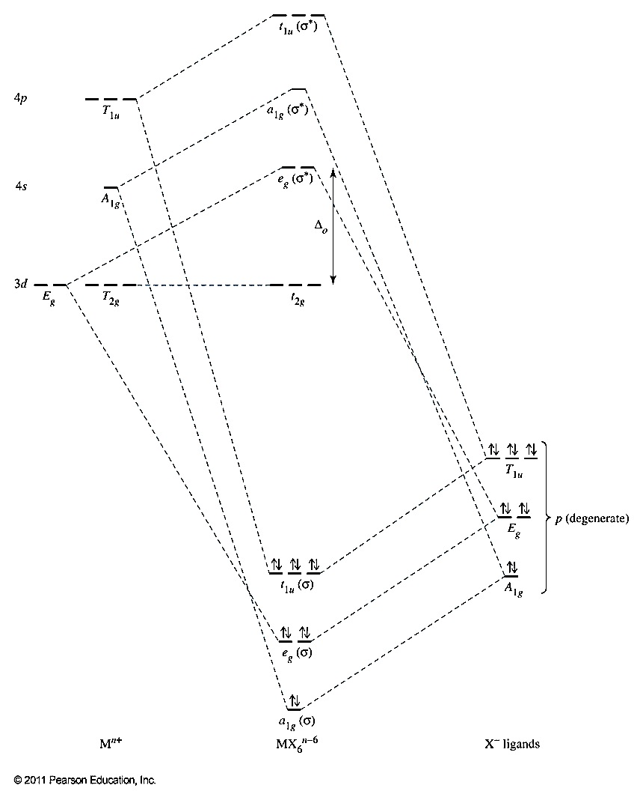Consider the molecular orbital energy level diagram below which applies to an octahedral coordination complex such as [Co(NH3)6]3+.



1. On the template provided, sketch the dx2-y2 orbital of Co(III). Put signs on the orbital lobes.
2. Give the Linear Combination of Atomic Orbitals that make up a bonding and an anti-bonding molecular orbital using the Co(III) dx2-y2 orbital and a combination of orbitals on nitrogen donors.

Ψ MOb = 3 dx2-y2 + ???

Ψ MO* = ???

1. On the Energy level Diagram, circle the LUMO of this complex. The complex is diamagnetic; therefore there are _____ electrons in the LUMO of this complex. What would be the expected μs.o.  and the ground state term symbol of the free CoIII ion in the gaseous state?
2. Suppose the complex in question is the paramagnetic complex, [CoF6]4-. How would the diagram will be modified (i.e., what happens to the HOMO/LUMO positions) for the paramagnetic complex, [CoF6]4-? What is the expected magnetism of [CoF6]4ˉ

***For Grading***

|  |  |  |
| --- | --- | --- |
| **Question** | Points possible | **Points received** |
| I | 32 |  |
| II | 15 |  |
| III | 30 |  |
| IV | 24 |  |
| V | 20 |  |
| VI | 40 |  |
| VII | 20 |  |
| VIII | 24 |  |
| IX | 20 |  |
| Total | 225 |  |

Name: ________________________________________

